**GOC Semesteraufgabe**

Team 1: Wöhrl, Wagner, Lidl

**Generelle Aufgabe des Agenten:**

* Beenden des Levels ohne zu sterben
* Erreichen eines möglichst hohen Scores

**Beschreibung der Umgebung:**

* Eine Strecke, auf der Hürden und Hindernisse verteilt sind

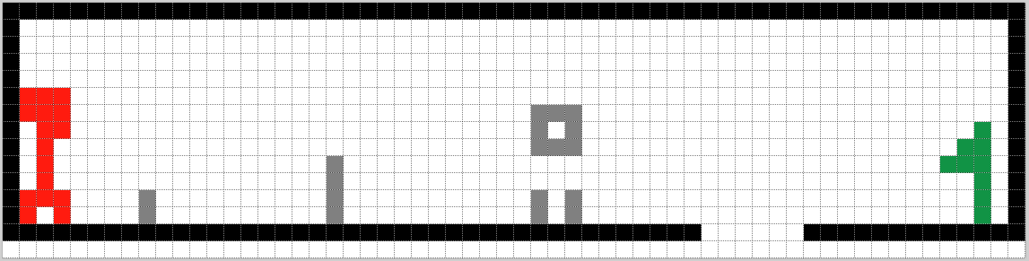

**Art des MEP**

* episodic

**Zustandsraum S**

* X-Koordinate des Spielfelds

|  |  |  |  |  |  |  |  |  |  |  |  |  |  |  |  |  |  |  |  |
| --- | --- | --- | --- | --- | --- | --- | --- | --- | --- | --- | --- | --- | --- | --- | --- | --- | --- | --- | --- |
| 0 | 1 | 2 | 3 | 4 | 5 | 6 | 7 | 8 | 9 | 10 | 11 | 12 | … |  |  |  |  | … | 57 |

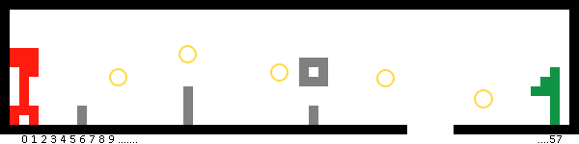

**Aktionsraum A**

Mögliche Aktionen: Laufen oder verschieden Arten von Sprüngen

* Regular jump -> 2 Units weit
* High jump -> 3 Units weit
* Long jump -> 4 Units weit

|  |  |  |  |  |  |  |  |  |  |  |  |  |  |  |  |  |  |  |  |
| --- | --- | --- | --- | --- | --- | --- | --- | --- | --- | --- | --- | --- | --- | --- | --- | --- | --- | --- | --- |
| 0 | 1 | 2 | 3 | 4 | 5 | 6 | 7 | 8 | 9 | 10 | 11 | 12 | … |  |  |  |  | … | 58 |
| Walk | Walk | Walk | Walk | Walk | … | / |  |  |  |  |  |  |  |  |  |  |  |  |  |
| Regular | Regular | Regular | Regular | Regular | … | / |  |  |  |  |  |  |  |  |  |  |  |  | Regular |
| High | High | High | High | High | … | / |  |  |  |  |  |  |  |  |  |  |  |  | High |
| Long | Long | Long | Long | Long | … | / |  |  |  |  |  |  |  |  |  |  |  |  | Long |

**Zustandsübergangsfunktion δ(s, a)**

Je nach Sprungart wird der Charakter um 2, 3, oder 4 Einheiten nach rechts in einen anderen Zustand bewegt.

|  |  |  |  |  |  |  |  |  |  |  |  |  |  |  |  |  |  |  |  |  |
| --- | --- | --- | --- | --- | --- | --- | --- | --- | --- | --- | --- | --- | --- | --- | --- | --- | --- | --- | --- | --- |
| x-Coordinate /Jump type | 0 | 1 | 2 | 3 | 4 | 5 | 6 | 7 | 8 | 9 | 10 | 11 | 12 | … |  |  |  |  | … | 57 |
| Walk | 1 | 2 | 3 | 4 | 5 | 6 | / | 8 | 9 | … |  |  |  |  |  |  |  |  |  |  |
| Regular | 2 | 3 | 4 | 5 | 6 | 6 | / | 9 | … |  |  |  |  |  |  |  |  |  |  |  |
| High | 3 | 4 | 5 | 6 | 7 | 6 | / | … |  |  |  |  |  |  |  |  |  |  |  |  |
| Long | 4 | 5 | 6 | 7 | -1 | 6 | / |  |  |  |  |  |  |  |  |  |  |  |  |  |

**Rewardfunktion**

|  |  |  |  |  |  |  |  |  |  |  |  |  |  |  |  |  |  |
| --- | --- | --- | --- | --- | --- | --- | --- | --- | --- | --- | --- | --- | --- | --- | --- | --- | --- |
| x-Coordinate /Jump type | 0 | 1 | 2 | 3 | 4 | 5 | 6 | 7 | 8 | 9 | 10 | 11 | 12 | … |  | … | 57 |
| Walk | 0 | 0 | 0 | 0 | 0 | -1 | -1 | 0 |  |  |  |  |  |  |  |  | 100 |
| Regular | 0 | 0 | 0 | 0 | -1 | 1 | -1 | 0 | … |  |  |  |  |  |  |  | 100 |
| High | 0 | 0 | 0 | -1 | 1 | 1 | -1 | 0 |  |  |  |  |  |  |  |  | 100 |
| Long | 0 | 0 | -1 | -1 | -1 | -1 | -1 |  |  |  |  |  |  |  |  |  | 100 |

*Rewards*

-1 : Charakter stirbt. Gewählte Aktion in aktuellem Zustand führt zum Tod.

10: Bonus aufgesammelt

100: Ziel erreicht